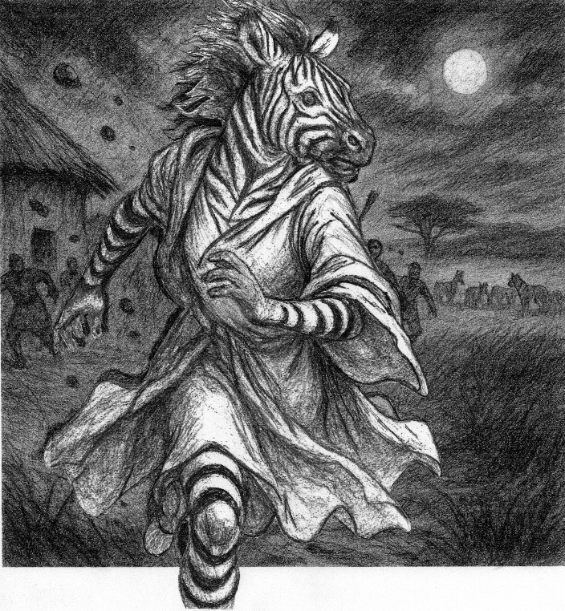
Reluctant Phoenix
02
Driven Out

Kamau and his friend Dalmur had been fighting a losing battle with their curiosity for days. If the Medicine-man had nothing to hide, what was the harm? If he had something to hide, then they would be doing the village service. Either way, they both thought they had seen a striped thing enter the hut near dawn, and they meant to have an answer.
Naja, Dalmur’s sister, was really the one who had seen something, and she had no idea what to think about it. Medicine men were already strange enough for her, and this one made marks on paper. The marks were nice enough to look at, but he had stacks of paper that could tell stories only he could hear. That was more than enough magic for her. Yet like her brother and his friend, she was drawn to see what he was really up to.
“There is a gap beside the door. See the light shine through it.” Naja had seen it many times while doing her evening chores. But Dalmur had to look like he was in charge, so she looked where he pointed, prepared to act suitably impressed.
Naja went to look through the hole first. Despite all their bravado, the boys had not worked themselves up to actually spying on the Medicine Man. “Be careful, you might see something you will wish you could forget.” She whispered this taunt to Kamau, whom she had a secret crush on, just as she bent to peep through the crack. Inside, she saw a woman with striped skin and a zebra’s head speaking with the Medicine Man. She was too shocked to hear more than the single word ‘father.’ “Mercy of God. He has brought a demigod among us.” Naja scrambled from the crack and ran to fetch the elders.
Dalmur thought his sister was playing him for a fool, so he casually crept up to take his turn at the crack. “Quickly get our spears.”
Kamau knew his friend well enough to understand the tone in the whisper. Even in the quiet hunter’s whisper, one must be looking at the other to hear it at all.
Dalmur felt his friend press the spear shaft into his hand as silently as a cloud might drift across the sky. “Are you ready?”
Kamau nodded. He had not seen inside the hut but trusted his friend and was ready to back him up.
“Father, when will you talk to the elders?”
“Zalika, I do not know what I will say to them.”
“Tell them what happened. What can they say?”
Salahuddin looked sad and very frail when he answered, “They will say I must turn you back… or turn you out. I fear the answer I must give them very much. I do not know how to turn you back or even where to look for that knowledge. I would have you walk with me in the sun, but if we do that, they will stone us both.”
“You are the Medicine-Man. They will listen to you.” Zalika's voice held a child's wonder at the thought that there was something her father could not do.
“When they look at you, they will see only the fear that stalks the dark places of their souls.” Salahuddin looked thoughtful for a moment. “I could tell them I have a spirit guide that has taken solid form. Perhaps they can accept that.”
“Father, what was that noise?”
Salahuddin looked to the door of the hut just in time to see two men enter cautiously with weapons ready. “Medicine-man, you will banish the demigod, or we shall kill you both.” Dalmur's matter-of-fact manner left no room to doubt the intention of these two men.
“Dalmur, this is my child transformed. Please do not hurt her.” Salahuddin said this as he rose to his feet to shield his daughter from the two warriors.
“Forgive us, Medicine-Man, you are possessed.” Kamau's face showed deep regret as he struck Salahuddin on the side of his head with his spear shaft. Salahuddin collapsed immediately.
Zalika meant to scream 'Father' as she rushed to her father’s aid. What came out was the wild noise of a terrified animal, followed by a sharp intake of breath and a short wine as the spear points of both men entered her chest. Then, a low moan as she fainted from shock and pain.
Three elders arrived to find Salahuddin motionless on the floor. Two young men striking courageous poses over a woman with striped skin and a cloth over her head, their spears thrust into her back. “What has happened here?”
Kamau stood as tall as he could and began telling a story of courage and combat until he saw Dalmur’s sister. Then he decided to keep it as simple as he could.
During Dalmur’s version of events, Salahuddin came to. “Kamau, Dalmur, what have you done?” He tried to crawl to Zalika, but Kagunda, first among the elders, stopped him.
“Salahuddin, what has happened here, and what is that?” They had been friends for a very long time, but tonight there was little warmth in his voice.
“This is my daughter Zalika. She was the one possessed, not me.” Kagunda allowed Salahuddin to go to the body on the floor. Salahuddin removed the cloth covering Zalika’s head and covered her body with it. He cradled her head in his lap and tearfully told of everything he had done since his wife died. “…I am hated by Allah for trying to take Kaddy from him. He has punished me by taking my daughter, my last child.” Salahuddin hugged the head and shoulders of his child’s changed body. While holding his child, he began rocking and singing a lullaby.
Kagunda motioned the two young men to leave the hut. “Mourn your child any way you choose, but you cannot bury that in the village.” Kagunda and the other elders left to join the two young men in the gloom of night outside the hut.
Kamau was the first to notice that the point on his spear was badly corroded. “Elder, Dalmur, what does this mean?”
Kagunda looked at the spear point as Kamau held it up. To him, it looked like an old spear point badly taken care of. “It means you take poor care of your spear.”
“Elder, this morning I could see myself in mine, look at it now.” Dalmur held up his own spear as he spoke. “What does it mean?”
“I do not know...” Before Kagunda could say more, there was a noise from inside the hut.
Zalika woke to the sensation of being rocked gently and the sound of her father singing a lullaby. For a brief time, she was a little girl safe in her father’s arms. “Father, what happened?”
At the sound of the zebra woman's voice, Salahuddin cried out and scrambled to his feet. This was too much. Certainly, his child would have been allowed into paradise. This must be a jinni sent to torment him for trying to change the will of Allah. In a panic, he moved away from the zebra woman, throwing whatever came to hand at her. “Get away from me, jinni!”
“Father, what is wrong? Why do you throw things at me?” Zalika tried to get to her father. The eight-year-old child wanted more than anything else in this world to be held in her father’s arms and to feel safe from the strange and frightening place the world had become since her mother died.
Salahuddin fled out of the hut into the gathering crowd, screaming for the mercy of Allah to stop the torment.
Zalika followed her father into the darkness. Immediately, the village began throwing everything that came to hand at the striped demigod among them. Zalika tried to explain who she was, but the people were in no mood to listen. To them, this was a nature deity to be feared and driven away, simple as that. Her pleas for her father were ignored.
When spears began being brandished about, Zalika looked for a way out of the crowd. She had no wish to experience the harmful end of a spear again. Seeing herself surrounded, she panicked and ran as hard as she could. She had nowhere to go but away. She crashed into people and huts. When she stumbled, she ran in whatever new direction she faced. There were endless people until suddenly there were none.
Alone in the dark, there was only brief relief. The smell of the village faded from her nose, replaced by scents of things that needed no other name. When she felt a tiny whisp of yellow lion in her nose, the need to be out in the open grassland quickly became too much to resist. There, where she could see even in the darkness, the panic began to subside. She felt safe running through open ground.
She knew there were other zebras nearby. She could hear them. When she found the herd, it felt like home. As she joined the herd, they all ran for a short while before the need to run just ended.
In the herd, she felt safe in ways that had no words. She missed her father, but that was yesterday. Tomorrow would soon be here, and today would be yesterday.
Among the zebra here and now was all that they had or cared to have. They never spoke, but she understood what everyone of them was thinking. They never worried about what might happen or what had happened. If one displeased another, the response was always the same. “Go away, feed the lion.” Nothing frightened or upset them more than being out of the herd. Alone was the worst thing any of them could imagine. They pushed, bit, and kicked each other for position in the herd. They scratched each other for comfort and called out when any got separated. They shared water and grazing.
Part of Zalika knew this. It was her life. It was all she could imagine. She did not question. A crowd of mares and foals was normal. When a stallion drove off a young male, it was not worthy of notice.
With nowhere else to go, she melted into the herd. With no sense of time other than now, and little sense of place other than here, she lost track of both time and place. With no one to talk to, language lost its meaning, just as a name is meaningless when there is no one to share it with. Her sense of self dissolved into the herd, and the part of her that had come from the herd found comfort in that.

