Primarina Caught Eevee
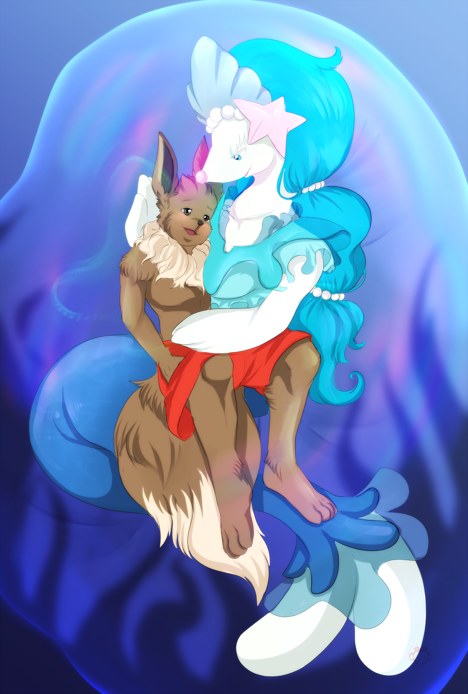
One night, Toko, an anthropomorphic Eevee was taking a walk on the beach, taking some time to cool off after getting into an argument with his roommate Uki. Not bothered by the cold, all he had on was his short pants, not even wearing shoes or sandals, allowing himself to feel the cool sand between his toes. The young man was fit, but had a modestly slender build, with a silky main around his neck, and had a slight discoloration in his left eye due to an injury he sustained when fighting a poison type Pokémon. Passing the beautiful palm trees to his right, and listening to the calm waves splashing on the shore to his left, the young Eevee looked up at the star-filled moonlit sky. Taking a deep breath, he let the sight of the endless sky above him ease his thoughts, losing himself in the dozens of twinkling lights above him. “She just doesn’t understand.” he sighed to himself, thinking over his options. “I'm strong enough to work on my own, if I don't want to work with a team, then that's my choice.”

Toko had been part of a rescue team for almost a year, making use of his skill in offensive hand-to-hand combat. Rescue teams are small squads of three or four Pokémon skilled in both combat and rescue operations, making use of their powers and skills to save other Pokémon, and fighting bad guys from time to time. Toko’s rescue team had a particularly successful record, with Toko being the heavy hitter who could even go toe to toe with a Machoke. But as things were now, he was having difficulty getting along with his team, even thinking about leaving them to work alone. His roommate Uki, who had been friends with him since childhood, strongly disapproved of this, saying it was irresponsible, dangerous, and egotistical. Uki was a beautiful Pikachu woman, an ex-marine, and a part-time lifeguard who understood the dangers of fighting rogue Pokémon, especially overseas. Toko cared little for her lecture and overprotective demeanor, leading to where he was now, alone in the middle the night on a secluded beach.

Trying to get Uki’s words out of his head, he slapped his cheeks a couple of times and began walking into the water, wanting to feel the cold waves against his fur. Toko walked into the tide until he was knee-deep, looking out into the dark horizon as he became lost in his own thoughts. Taking another deep breath, he closed eyes and slowly breathed out, wearing a confident expression on his face. "I don't care what Uki says, I can take on any Pokémon that wants a piece of me.” Toko huffed. Then, he heard a soft innocent giggle echoing from below him, spooking the Eevee as he looked around to see who was there. When he looked down, he saw a pair of sparkling sapphire eyes looking up at him from underneath the water. Not moving, they just stared at him curiously, as did Toko who honestly didn't know how to react. But then, he felt something soft and blubbery wrap around both of his ankles, tugging him off his feet as he was suddenly pulled into the water. “Waaahhphfff-gurgle.” The Eevee's screams were short-lived as he quickly disappeared into the water.

His eyes closed shut, and found himself pinned underneath what he could only assume was a pair of large flippers, unable to pull away as he was met with a mouth full of saltwater. Toko hadn’t even the time to take a breath of air before submerging, as he felt himself plunging deeper and deeper into the sea. The Eevee tried to push off whoever had grabbed him, but their hold on him was firm and inescapable… if not a little bit comfortable. As he tried to prevent any water from entering his lungs, he heard another echoing giggle from his assailant. With that, he was released from the strong flippers, left flailing about and overcome with panic. It was like he had forgotten how to swim, he was never really good with water, but now he was just swinging his arms and legs about in fear.

Toko couldn't see anything, and he didn't know how deep he was, or what his assailant was going to do to him. Then, he felt something soft and squishy pushing against the front of his body, pressing against his face and wrapping around him, like some kind of elastic sheen. Before he could make anything of it, he was squeezed through the strange film, permeating through it as he was met a refreshing breath of much-needed air. After catching his breath, he opened his eyes and found himself laying on his back, now resting against the same membrane that had squeezed against him moments before. Toko could see the ocean around him, he was still submerged under the sea but protected by a glossy tinted surface. Attempting to sit up, he found it hard to balance as the soft floor slipped underneath him. The strange gel had surrounded him, taking on a spherical shape, and providing him with a breathable environment in the form of a Pokémon sized air bubble.

"A… bubble?” he said puzzled. Toko's mind was completely blown, it felt like he was looking at the world's largest aquarium, even able to see the moonlight shining through the water above. Then, he saw a Mysterious silhouette on the other side of his prison, slowly approaching him has another echoing giggle surrounded his bubble. Placing two of its fins upon his prison, the mysterious stranger began stretching the film inwards until it slipped through with a wet splash, allowing the Eevee to get a clear look at the creature. Toko gasped, sitting before him was a beautiful Primarina woman, staring down at him with pride as if she had just caught a meal. With snow white glossy skin, a shiny blue mermaid tail, and beautiful silky hair, the very sight of her left Toko speechless in awe. The marine Pokémon also wore an azure ruffled top, just big enough to cover her breasts, even puffing out her chest in a provocative way in hopes that the Eevee would take notice. But what stood out to Toko the most was her pearly sapphire eyes, gleaming like the same ones he saw between his legs before being pulled underwater. Recognizing her as his captor, Toko just scooted back cautiously, the Primarina chuckling playfully as she crawled her way towards him, her massive tail lapping behind.

His captor's flipper-like arms were large, no question that they were big enough overpower him like before as she inched closer to him. However, Toko was taken aback, he had never seen a Primarina this close. Rarely ever did marine Pokémon live above the water, or even hang around beaches during late nights. With a mischievous giggle, the Primarina wrapped her arm-fins behind Toko's back, and pulled him close as she took his lips in a surprise kiss. "Mmmmm!?” Toko Muffled in surprise. The Primarina had closed her eyes, wearing a serene look on her face as she pressed her lips against his. For a moment, the young Eevee found himself completely entranced by her, before shaking it off. Even though the mermaid Pokémon wasn't using attract, he could feel his heart skip a beat, his cheeks becoming slightly rosy.

Regardless, he lifted his arms up and tried to push her away, their lips parting for a brief moment as he gained some leverage. But she retaliated, wrapping her right fit around the back of his head and pulling him back into her kiss. “Mmm-Mmph…” he moaned, still trapped in her embrace. The Primarina tightly held him against her body, her arms wrapped around him so firmly that he couldn’t pull free anymore. Toko was shocked to find that her strength practically dwarfed his, but her hold was surprisingly gentle, strong enough to keep him pinned, but tender enough not to hurt him. What's more, her skin felt so nice against his fur, smooth and slippery like blubber, but also slender and soft, with her belly pressing against his. Toko hated this feeling of helplessness, knowing he had the strength to fight her off, but deep down... he didn't want to hurt her. After all, she wasn't causing him any harm, just holding him and kissing him, like some kind of aggressive flirting.

Though not completely accepting her affection, he relaxed in her arms, allowing her to freely make out with him. The Primarina took this as a surrender, giggling happily as she continued her playful kisses. Easing up, Toko found himself blushing at the mermaid’s gentle touch, noticing how truly pleasant her smooches felt. The Primarina’s lips were as soft as mochi, and warm like homemade tea, providing him comfort akin to sitting near a fireplace with a warm blanket. Letting his guard down, the Eevee let out a calming whimper, truly surrendering to his loving captor. Just then, the Primarina parted her lips from his, giving Toko with flirty smile. Looking him in the eyes, she let out a comforting sigh, taking a moment to stroke the back of his head as Toko was again awe struck by her beauty. Leaning closer to her captured prey, she gave him a gentle peck on the forehead, his cheeks becoming rosy again as a small embarrassed smile could be seen on his face.

The Primarina then kissed him on the nose, giving him another playful look with her sparkly sapphire eyes. Unable to look away, Toko’s heart skipped a beat, losing himself to her charms as he relaxed in her flippers. Not stopping there, she then kissed him on the cheek, then on his other cheek, then on his forehead again, and on his cheek once more. The Primarina was repeatedly smooching his flustered face with no signs of stopping, keeping her flippers wrapped around him while practically drowning him in her affection. Loving his captor's undivided attention, Toko started giggling under his breath, her kisses tickling him. Turning his head left and right, he attempted to avoid her kisses, as his innocent giggles turning to laughter. “S-s-stahahap!” he pleaded, stuttering between giggles. Toko's struggles did him no good, as she would land each and every kiss directly on his helpless face, he couldn't escape her loving hold, nor could he ignore her charms.

Realizing that his pleading was pointless, he continued squirming as he was kissed again and again, still smiling ear to ear. Toko closed his eyes as he laughed with joy, rendered helpless to her smooching treatment. Suddenly, she once again locked her lips with his, hugging him back against her body as she quickly silenced his muffled laughter. Toko quickly calmed down, allowing her lips to take him as his giggles faded away. The Eevee once again closed his eyes, losing track of time as he enjoyed his first make-out session in the Primarina’s private bubble. After some time, she released his lips, looking down at his embarrassed face as he opened his eyes and looked back at her with a yearning gaze. The mermaid Pokémon then picked up his legs in her left flipper, leaning back against the bubble as she cradled the Eevee in her arms, and letting his head rest against her shoulder. With a playful giggle, she gave him an affectionate smile and began murmuring something under her breath.

The Primarina started humming, letting out a soothing melody with Toko as her audience. The Eevee happily listened to her song, another embarrassed smile appearing on his face as he patiently relaxed in her arms. Finally, she opened her mouth, revealing her soft voice as she began a calming breathtaking song. Toko was silent in awe, eyes widened and lost for words as her melody flowed throughout the bubble. The Primarina's voice was so beautiful, like listening to a wind-chime in a gentle breeze, or the waves lap against the shore. Toko didn’t dare speak, not wanting to make a sound that would interrupt her singing. The bubble was perfect for a performance like this, her voice gently echoing throughout the sphere, accompanied only by the soft ambiance of the ocean.

As the Primarina continued her melody, Toko fond it difficult to keep his eyes open, as if his eyelids were growing heavy. Noticing his fatigue, the Primarina began to slowly sway her arms side to side, rocking Toko to help him sleep. Then it dawned on him, she wasn’t performing a song, she was singing him a lullaby. With every passing moment, he became more and more drowsy, her song soothing him into a state of tranquility. Toko tried so hard to stay awake, but his eyelids slowly closing, just barely keeping them open on his own. Though try as he might, the young man couldn't resist the mermaid's melody, as he found himself drifting off in her arms. "I don’t wanna go to sleep, I want to hear... her song…” he thought, before finally succumbing to the Primarina’s Lullaby. Even as the Eevee fell asleep, she continued singing for him, watching over him as she happily giggled at his sleeping face.

Even in his sleep, he could hear her voice, his dreams appearing as waves in the sea, flowing to the tune of her song… Until… “Toko!” a voice called out. Toko slowly opened his eyes, seeing the dark starry sky above him. “Toko!” the voice shouted again. Slowly sitting up, he looked to his left to see his friend and roommate Uki running down the beach towards him, wearing nothing but shorts and her lifeguard T-shirt. However, Toko just sighed, realizing that his encounter with the mermaid Pokémon was just a dream. Running up to his side, she looked down at him with relief.. “You were gone for so long! Don’t worry me like that!” But then, she paused, tilting her head at him curiously before smiling in amusement. “Pfff… What happen your face?” she asked. “My face?” Toko replied curiously, touching his cheek with his right paw.

Unknown to the Eevee, he was rubbing at the many, many blue kiss marks on his oblivious face, rubbing it off on his paw like it was lipstick. That's when they both heard a whistle coming from the waves in front of them, sounding familiar only to Toko. Floating in the shallow waves only a couple yards away was the Primarina from before, giving Toko a flirty smile as her skin glistened in the moonlight. Pressing her fin against her mouth, she blew him a kiss in the form of a pink heart-shaped bubble about the size of her lips. Slowly floating its way him, the bubble gently pressed against his soft cheek, nuzzling him playfully before popping into pink mist. “Ahh! ❤” Toko suddenly let out a euphoria moan, feeling a wave of pleasant warmth spread from his cheek to the rest of his body, giving him the same sensation as one of her hugs. His cheeks blushing a rosy shade of pink, he took another look at the Primarina, who gave him a playful wink before disappearing back into the ocean.

Uki just giggled, giving Toko a smug grin as she kneeled down next to him. “Well well… someone's been lucky.” she joked, patting his bare back. After a moment of silence, Toko sighed again rubbing his paw against his cheek, still feeling the warmth of her strange kiss. "Uki…” he said, pausing as if unable to finish his sentence. “Yes?” the Pikachu replied, leaning forward to look him in the eye. “You were right… there are some Pokémon that I just can't handle on my own."

©ToastManMcFace

Pokemon belongs to ©Nintendo & GameFreak

Other Hug Stories⬇
The Tickle Belly Dancers
A Kitsune Stole My Heart
The Fox and The Puppies

Other Bubble/Balloon Stories⬇
Renamon's Strange Swimsuit
The Lab Incident - Commission
Squeaky Halloween Trap

Want to support my work? Patreon
Want to tip me? Ko-fi

