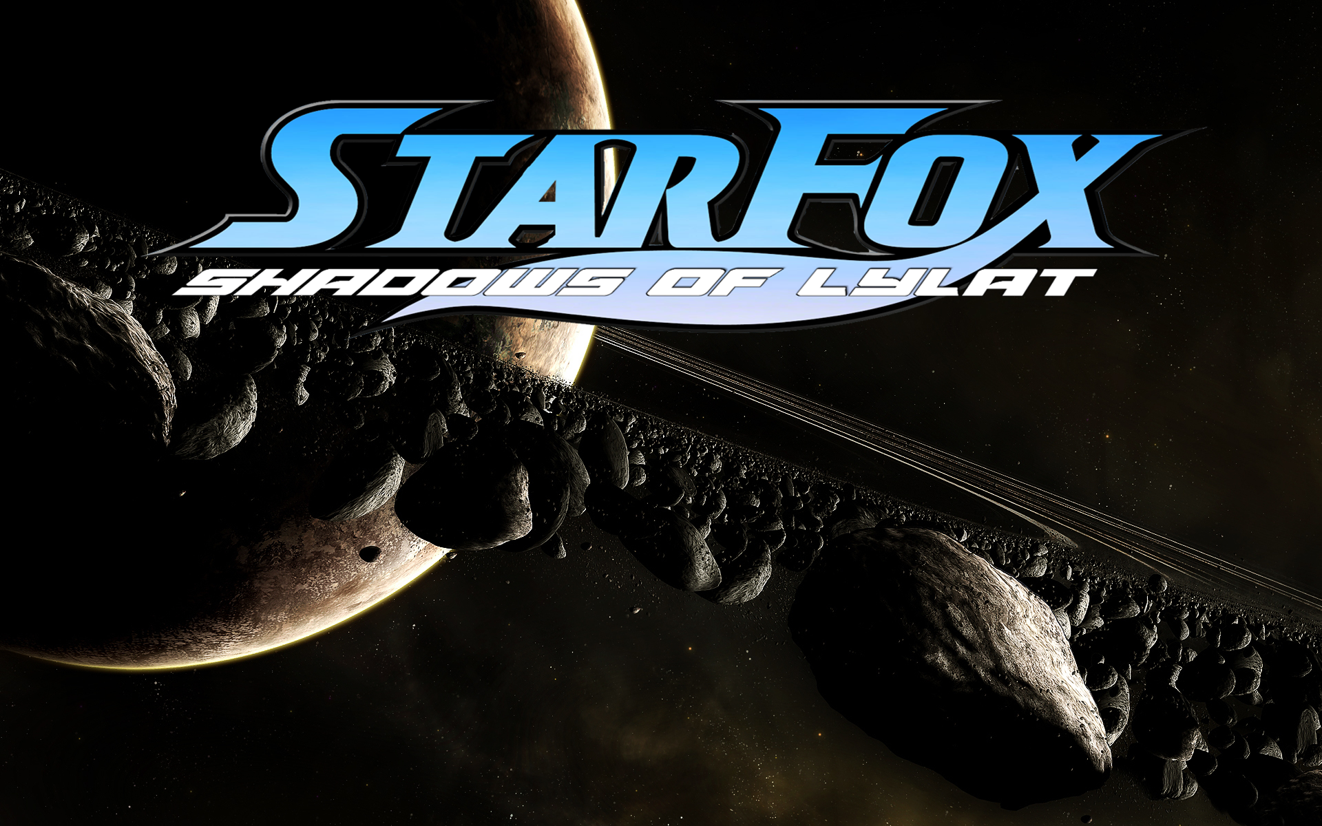

Two guards a stood on either side of a closed stainless steel closed door or a Solitary confinement prison cell. One of the guards a Great Dane shifted his posture a little the looked at his companion a tabby cat.

“What do you think they are going to do with this guy?” he said motioning to the door between them referring to the occupant inside. The Tabby glanced at the Dane trying to keep his vigil but answered

“Since the end of the Lylat war with Venom defeated the counsel is going to want to deal with them. Far as I know the person inside is responsible for Planet’s downfall. The Military defense counsel wants to keep a lid on this guy for some reason though. Can’t imagine why I used to vacation on it, can’t believe it got turned toxic was such a paradise. Press would also just love to tear them to shreds can’t say I blame them either. Rumor is though that this guy is connected to our forces somehow, which doesn’t make sense why the counsel wants to keep this quiet them being a traitor and all either way. I personally think they should just execute them or let them rot in a cell for the rest of their days.” The Dane nodded to his friend then he turned to look in the small square glass window that viewed the cell looking at the prisoner.

The tabby tapped him alerting him to the presence of a group of soldiers heading for them followed by General Pepper. They both straightened up and saluted the General as he approached them. The old War hound motioned for them to open the cell. The Dane nodded typing in a command code in the security panel and the door hissed and opened sliding up into the ceiling. Pepper walked in to see the prisoner a dark grey wolf sitting cross-legged on the floor with their head looking down but raised it when Pepper made himself known.

“So the time is now then.” The Prisoner said standing up and turned to walk over to his bed and put on his Venom officers dress uniform. Once he was done the Dane walked in and cuffed him escorting him out with the General. Pepper Walked beside them. “Everyman must stand accountable for his actions that they have made in life. You are no exception to the rule Commander.” He said to the man walking with him down the corridors. The wolf held his head high not looking at the old hound, “Which is why I surrendered peacefully and cooperated during the war. I have far more than just the planet to answer for. The counsel should just make this public. The General shook their head at this.

“You know of all people should know why we cannot do that.” He said looking at the prisoner. “The press would have more than just a field day. It would ruin more than your reputation but both your family’s reputations. Both good and notorious.” At this the prisoner stopped dead in his steps, “My family is none of the Counsel’s concern… Both my last two family members can take care of themselves even with that being known. One already knows what I’ve done…. The other doesn’t even know I exist and be…” “And would be better off not knowing, especially right now.” The Pepper finished for him then the continued for the rest of the way in silence.

As they walked outside the prison they were greeted by a stead down pour of rain as the walked out into it and into a transport lifting off. The prisoner watched from a window as the sped out of sight of the island prison he was previously held at. It wasn’t long before they came to Corneria Defense HQ and landed on a platform. Guards marched out of the building to meet the Generel Pepper and the prisoner both were led into the main council court chamber of the planet. The court room had an audience of people that glared at the arrival of the prisoner dressed in a Venom officer’s uniform.

“Commander Lorek O’Donnell Step forward.” The General said from his seat. Lorek did so looking at the council, “You have been brought forth here today to answer for the charges of your involment in the now recently Ended Lylat wars your guilt has already been decided by yourself and this council. Do you have anything to say before your sentence is given?” he asked the Lorek.

Lorek closed his eyes then nodded opening them. , “There is nothing I could say that would justify what I have done…. For the devastation I caused or the lives I ruined and ended. My own life coming to an end wouldn’t even bring solace to those wanting justice. One life versus a planet and those that lived on it. My life, reputation, desires are forfeit.” He said solemnly thinking that those words would be among his last but content with it. The council looked at each other whispering among themselves then they nodded. This time it wasn’t Pepper that spoke but a councilwoman.

“Commander Lorek. The co-operation and help you have provided during the Lylat war after your defection was commendable but does not out weigh the monstrous acts of crime you have committed. General Pepper believes that you are worth to give a chance at redemption. You are hearby placed under the strict command of General Pepper and his future Successor running black-ops doing what good men and women cannot and be a silent sentinel for Lylat and retain your rank as commander.” Then the court’s mallet was struck and the council members moved out of their seats. Lorek simply stood stunned thinking he was to receive the death penalty but then again in a way he had. He was appoarched by Pepper whom placed a paw on his shoulder as Lorek’s cuffs were removed and then led him away.

