You were walking down the wedding isle, alongside your soon to be mate, King Cobra. King Cobra wasn't just his name, it was exactly what he is. Indeed, you were in fact a human who was marrying a snake. Sometime it felt a bit surreal to think about it, wondering how this interspecies relationship would work, but all those thoughts would dwindle away when you and King Cobra would look deeply into each others eyes and remember just how much you two love each other.

The two of you came to a stop at the podium in front of the priest and waited for him to begin the ceremony.
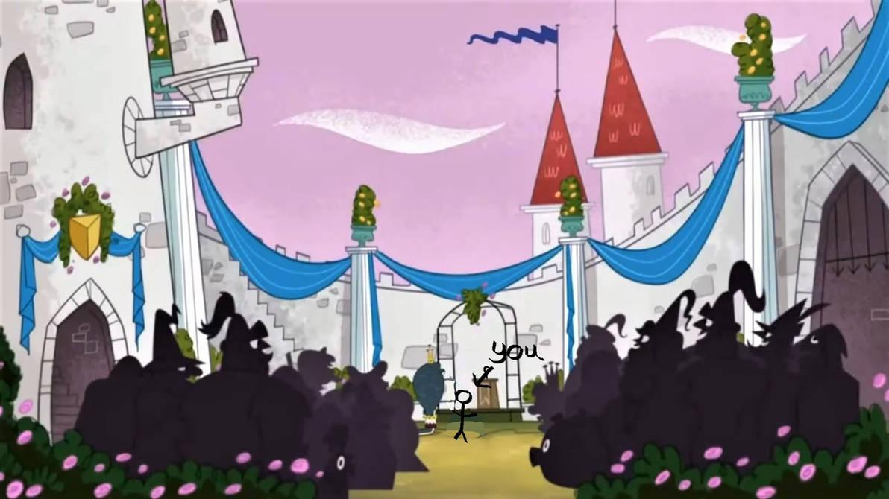
As you stood there next to King Cobra, you couldn't help but think back to when it all started, when you and him first met.
You were enjoying a hike through nature when suddenly you tripped over something and fell down. When you turned around to see what you tripped over, that was when you saw him.
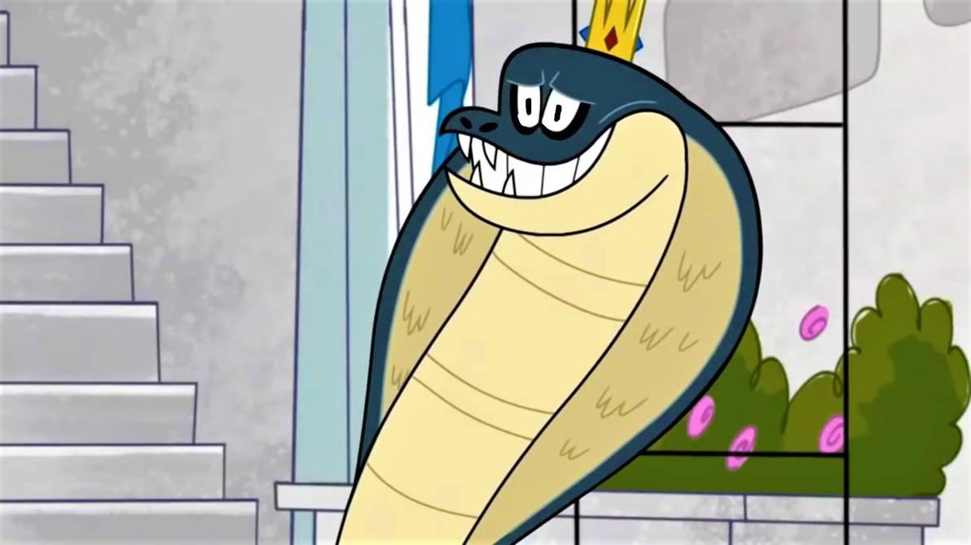
King Cobra slithered over to you and helped you up with his tail. He said that you accidently tripped over his long body and that he was sorry for just leaving it "lying around." You couldn't help but giggle a little and told it it was fine.

It was then, when the two of you looked intently into each other eyes, that it was love at first sight. You nor King Cobra could explain it, but the two of you just felt some sort of romantic bond for one another.

The two of you got to know each other over time and learned that the two of you seemed to share many common interests. You also learned that "King" Cobra wasn't was just his name and what he was either. He was actually the king of all reptiles, and that on the day met first met, he just happened to be on his morning hunt.

After some time together, the two of you decided to officially become mates and elope. When other people, reptiles, and other animals first heard about this they were a little confused. They didn't understand why a human and a snake would want to marry each other, but that confusion quickly dwindled when they all saw how close and in love the two of you were together. Everyone decided to just accept it and be happy for you two.
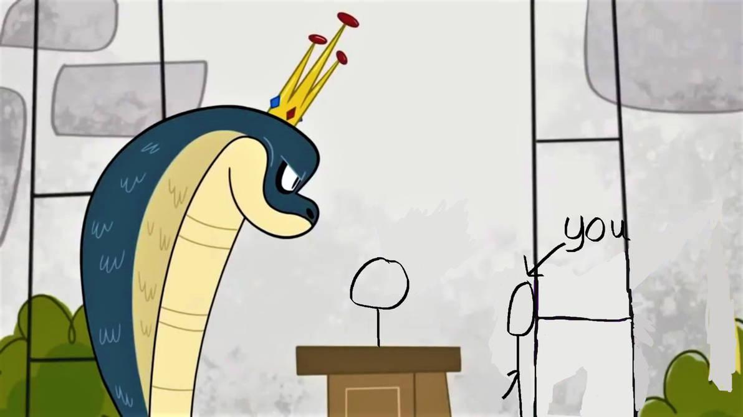
You and King Cobra turned to face each other as the ceremony begin. You also noticed the crowd watching happily. You saw many humans, reptiles, and other animals watching with big smiles, happy for the two of you.

"[Y/N], King Cobra, would you please read your vows to each other." the priest said.

You nod and begin to speak your vows first. King Cobra leaned his head down closer to you and smiled as he listened intently.
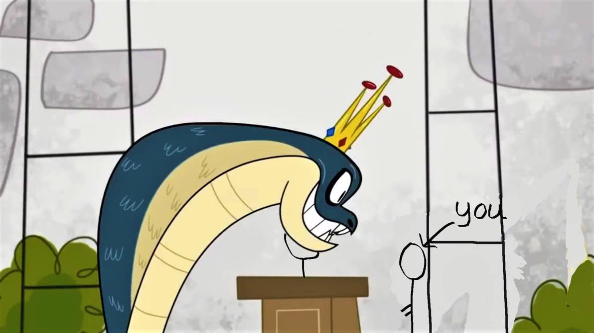
"I [Y/N], solemnly swear to always love and protect you King Cobra, and to do everything in my power to ensure that we stay together as mates." you say happily to him.

King Cobra smiles very lovingly at you before clearing his throat and delivering his vows to you.
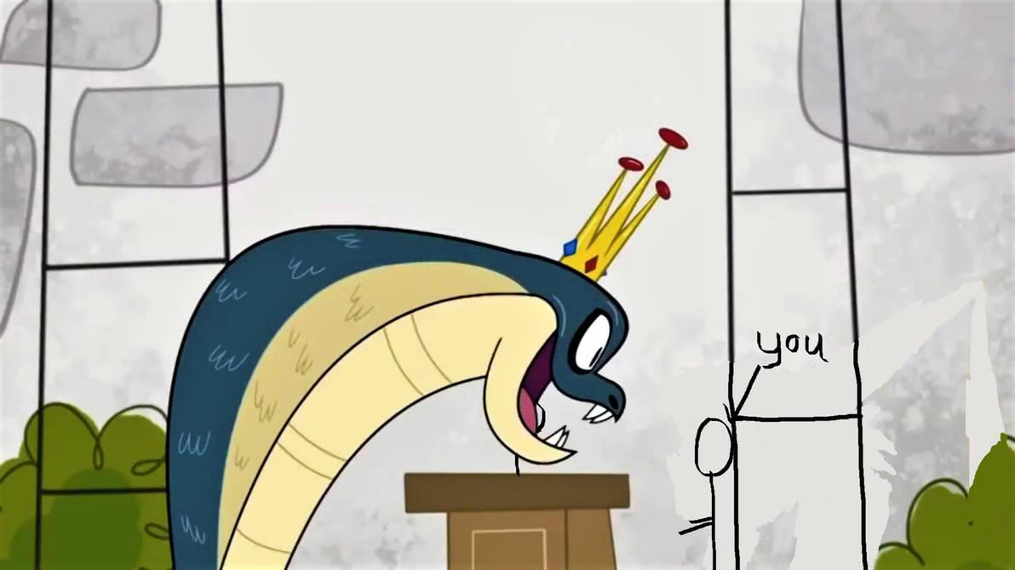
"I King Cobra, also sssssolemnly ssssswear to alwayssssss love and protect you [Y/N], and to do everything in my power to ensssssure that we sssssstay together assssss matessssss~." he hisses happily to you.

You smile just as lovingly back at him.
The priest began to speak again. "[Y/N], do you take King Cobra to be your mate, now and forever?"
You stare lovingly into King Cobra's eyes as you speak. "I do."
"And do you, King Cobra, take [Y/N] to be your mate, now and forever?" The priest asks.
King Cobra leans his head down to you and hisses "I do~."

Suddenly, he slithered his long and forked tongue out of his maw and began to lick your face, giving you a barrage of snake kisses.
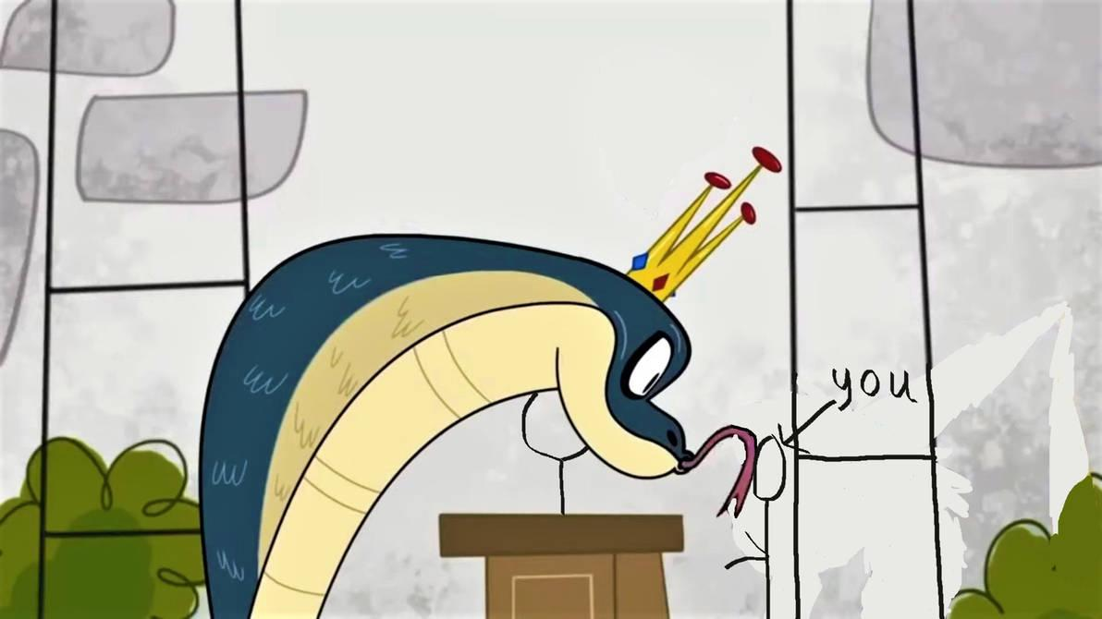
You giggled as his tongue tickled your face. After a moment, he eventually stopped.
The priest says with a smile, "then, by the power invested in me, I now pronounce you mates!"

The crowd erupted in applause and cheering, happy for you two. You and King Cobra hugged each other tightly, tears in both of your eyes.

"King Cobra." the priest speaks. "You may now eat the human."

When you and King Cobra met, one of the things you both learned you had in common was a love for vore. You both loved the idea of it. King Cobra has always loved to be the predator, feeling his prey squirming inside him, and you have always wanted to be the prey, being inside your predator in his warm and cozy belly. So the two of you decided that during your wedding, you two would commemorate your ceremony by having King Cobra eat and swallow you down into his stomach, instead of the usual kissing.
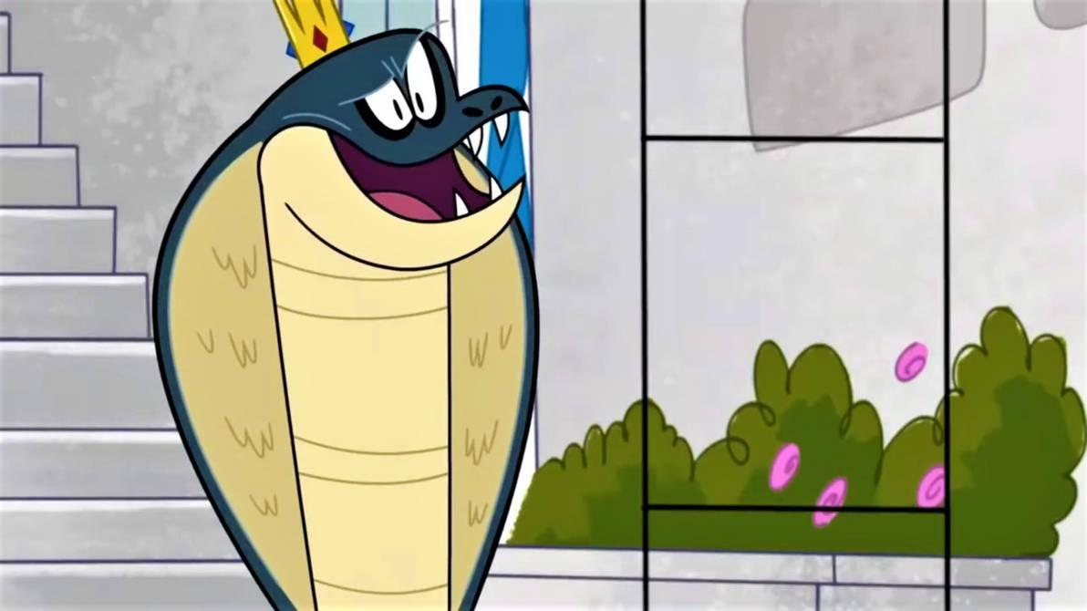
You looked at King Cobra with a smile. "I've been waiting for thisssss moment for a long time [Y/N]. Ooh, I jussssst can't wait to feel you sssssliding down my long ssssslender coilssssss, ssssssliding under my ssssscales and into my sssssstomach~." He hisses.

"I can't wait either." you say to your mate.

"Well then, let'ssssss not wait any longer~." he hissed before moving his head down towards you.
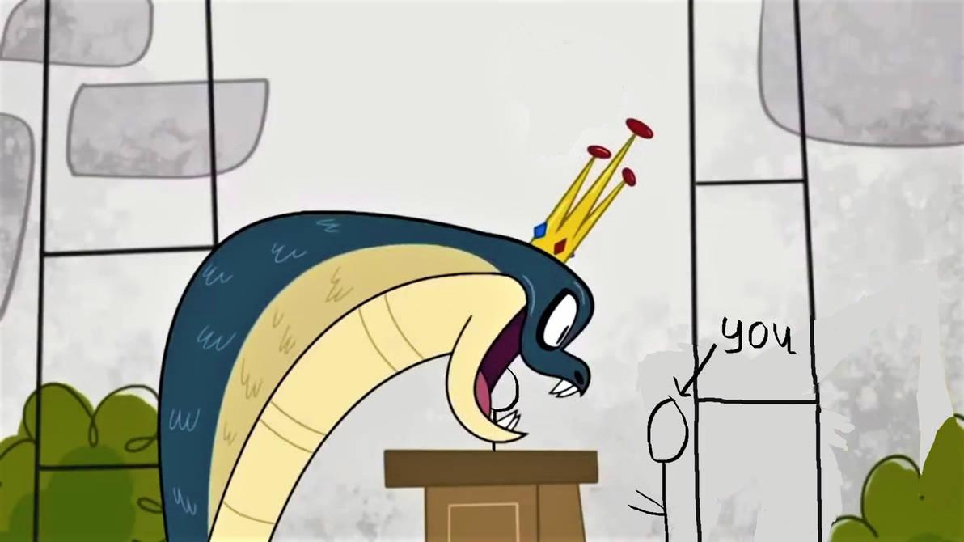
King Cobra opened his maw widely in front of you as you prepared to devour you.
With King Cobra's maw open in front of you, you were able to see his four sharp fangs inside his maw. You also he all the way down his throat, down into the abyss of his snaky body. As his maw was open in front of you, you could also feel his warm snake breath blow onto your face. King Cobra's breath smelled like many different fruits and vegies combined with various meats of different prey he has caught in the wild.

King Cobra moved his maw closer and closer to you before stuffing you into his maw with the help of his tail which he wrapped around you.
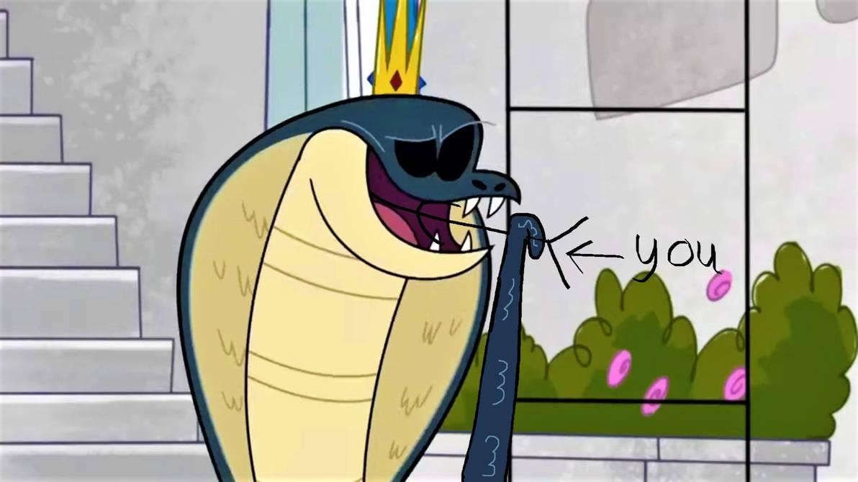
Everything was now dark, you could not just barely make out the walls of King Cobra's throat. Your mate continued to push you deeper and deeper until finally...
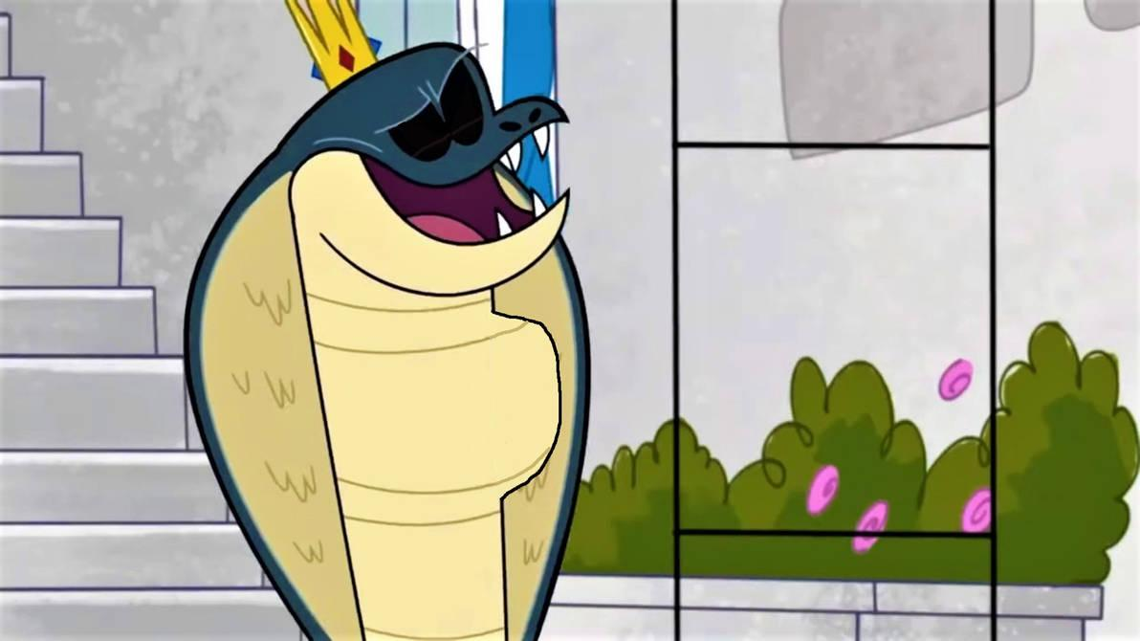
*GUUULP*

In one big 'gulp', King Cobra swallowed you down his gullet, sending down his snake body.
As you began is slide down King Cobra's throat, you noticed how easily and effortlessly it was capable of sending you down. On the outside, King Cobra, and everyone else watching the ceremony watched as the newly form bulge in his neck slowly descended down his throat and continued to travel through his coils. After some time you began to hear King Cobra's breathing become louder as well as his heartbeat. Soon you also began to hear the rumbling of his belly before you were stopped for a second before being pushed through a small sphincter, and finally, you were deposited into King Cobra's bubbling stomach.
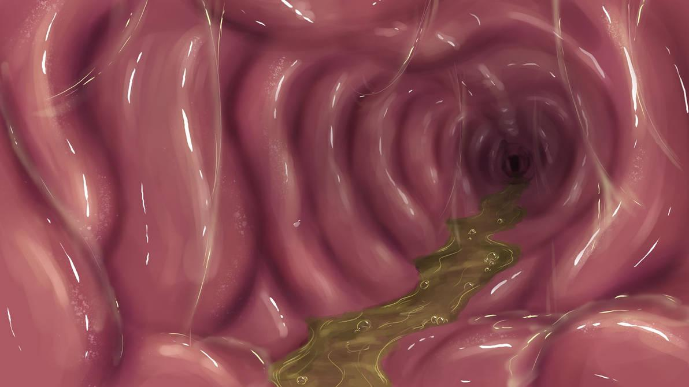
Once you were squeezed into King Cobra's stomach, you were immediately being pressed all around by warm loving flesh. His stomach walls were all pressing around you comfortably, it felt nice, like you were laying in a warm sleeping bag.

With a happy smile, you began to rub your mate's stomach walls, eagerly massaging his stomach.
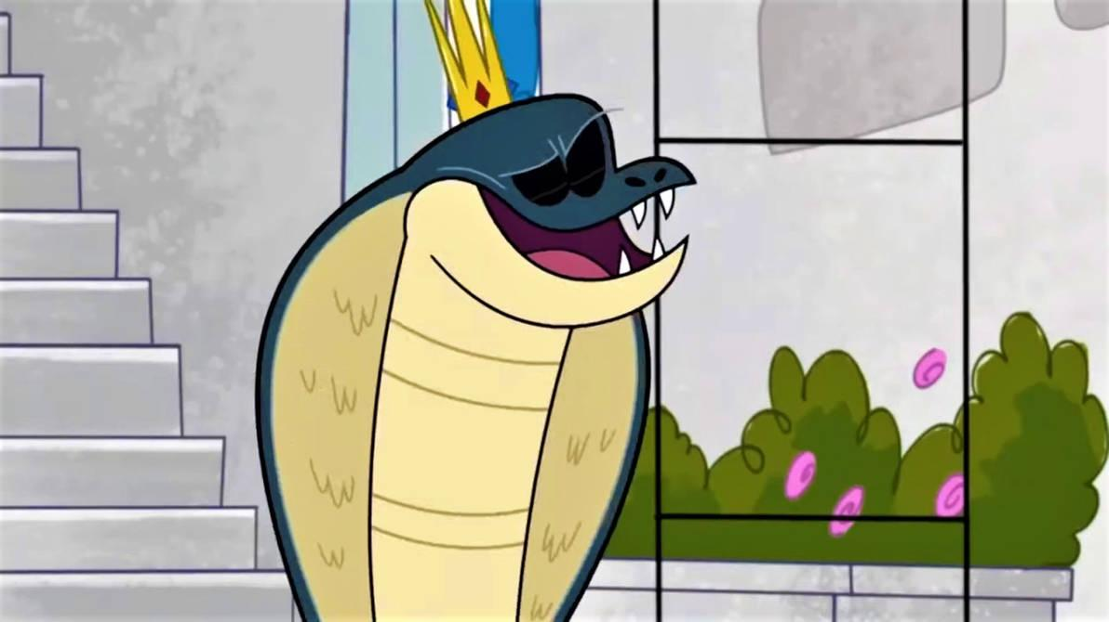
*BBBUUUUURRRRRRPPPPP*

On the outside, King Cobra let out a loud hearty belch, from the belly rubs. With a happy and satisfied sigh after his belch, King Cobra looked down at the bulge in his belly with a smile.
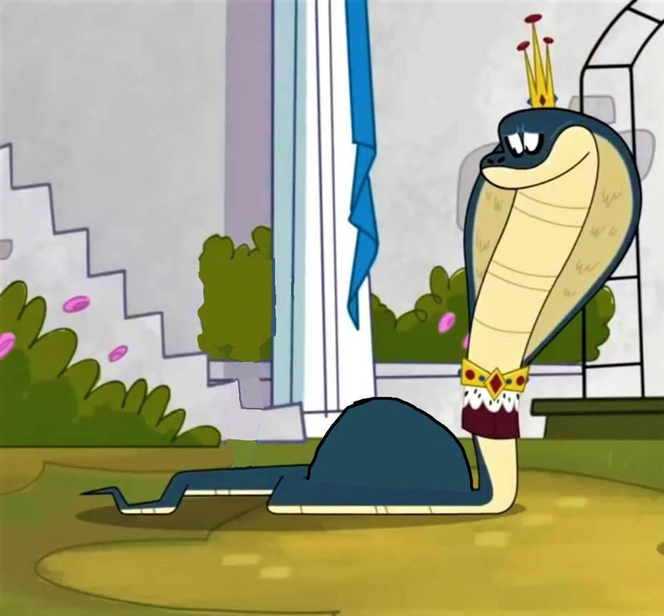
"My, what an abssssssolutely lovely meal you made [Y/N]~." King Cobra hisses while rubbing the budge in his belly with his tail. "I love you, my mate. Now we can be together forever~."

You smile and say "I love you too, my mate. I enjoy it in here as well. I fells nice being this close to your heart."

"Come now, my mate. Let usssss ssssslither home together~." King Cobra hissed.

With that, King Cobra began to slither back home with you inside of him. The crowd all cheering and applauding you two, happy the two of you to become mates. You and King Cobra smile happily, delighted to be mates now and forever. You both knew you two would live happily together for the rest of your lives.

THE END

