A Furry Wonderland Story

By Decus Q

Prologue
Wonderland Today

Wonderland is a world different from our own by any standards, nonsense makes sense and sense makes nonsense. A world where anything and anyone can exist with a little bit of imagination, in fact it was created as a world where imagination becomes reality. Whenever we imagine something in our minds it will appear as a living creature or a tall building, the possibilities are endless. The only traveler to ever come to Wonderland was a little girl named Alice. Since then Wonderland has made her legend in the eyes of the people. The one who sealed away the Evil Queen of Hearts Grizelda, the one who brought peace back to Wonderland; by doing so she became the new Queen of Hearts and ruled for many years. She improved Wonderland and turned it into four kingdoms represent by each symbol of the cards. The Heart Nation in the North, the Diamond Nation to the south, The Club Nation in the East and the Spade Nation in the West. These Kingdoms of Wonderland ruled with Peace and prosperity for all of Wonderland, as it’s main goal. Afterwards, Queen Alice vanished without a trace leaving only behind a few scrolls, one of which read….

“ I must return to my previous life, I could not stay forever even if I wished it. I entrust the Nation of Heart to the Family of Brave and I leave my final thoughts with the Balance of Wonderland. If for any reason Wonderland is in serious danger I have created a spell that will return me to this wonderful world no matter what. I thank the family of the White Rabbit for their service to the Kingdom and wish they continue to do so. My heart is heavy with this decision, but I must leave for now. May the Four Kingdoms always remember the true goal of Wonderland, to prosper with peace in mind.

Sincerely
Queen Alice Liddle”

For over two hundred years Wonderland prospered in peace, until now….
Chapter 1
Arrival of Alice

In the Tall Tall Forest there is a small cabin made of wood, leaves and other materials. A chimney made of rocks puffs smoke from it’s top with the sweet smell of Sweet berries and Crab Apple porridge. And inside the cabin is a Kangaroo mixing the small pot not to let the porridge burn. This kangaroo isn’t quite dressed for the morning; he is wearing a red baseball cap, a long green robe, and white pajama bottoms with very long blue slippers for his long feet. He scoops up a dash of the porridge and smells it; he then lightly tastes it to see it is ready.

“ There’s nothing like Sweet Berries and Crab Apple Porridge in the morning,” he spoke to himself, “ I just wish the Crab Apples wouldn’t pinch so much.” He looked at his paw to see a bandage as a reminder of their claws.

Suddenly a loud rumble began to shake his house.

“ What’s going on?” he shouted.

He darted outside to try and see what was making such a terrible commotion. He looked and saw the sky seem to split open. There lied a black hole in the sky; it was a sight to see but frightening to look upon it. Then something happened, a small golden ball of light began to descend form the hole. As it did the hole in the sky closed up and looked like it was never there to begin with. The kangaroo watched as the ball slowly descended into the Tall Tall Forest maybe four giant’s feet at the least away from his cabin. He rushed back inside and put on his daytime clothing instead. He replaced the robe with a green t-shirt and his pajama bottoms for a pair of shorts. He kept his red hat on and rushed out the door. He bounced high above the Tall Tall Grass forest in order to try and spot where the ball landed. For a moment he spotted it and he saw the light was beginning to fade away. He bounced as fast as he could to see what it was trying to avoid the Tall Tall Grass. Finally he landed near the sight where the light still shined faintly, he caught his breath and began to walk towards the light.

As he approached the light it began to reveal something the dimmer it was. Finally the light vanished and there was a young girl lying on the ground. The Kangaroo was astonished that a young girl would have fallen from the sky, but here she was. Long blonde hair reaching to her waist, cream white skin and a strange garment wrapped around her body. She wore what looked to be a checkered blue and black jacket over a white shirt, a small shirt that went to her knees and black shoes that covered white socks. On her back was a satchel he could see he had never seen anything like this before. He stared at her wondering what was going on, it wasn’t everyday that strange girls fell from the sky wearing amazingly small outfits.

He decided to carry her back to his cabin and nurse her back to consciousness. He picked her up and placed her on his back and began to walk back to the cabin. The entire time he carried her questions arouse in his mind, but the one that appeared the most was…

“ Where in Wonderland did you come from?” he asked himself.

Meanwhile….

Elsewhere in the Hall of Balance a counsel was being held over the recent events. A single light that could only show four figures sitting at a round table each dressed in a robe signifying their nations symbol only lighted the hall.

“ The time has come for the next coming of Queen Alice,” the Diamond Robe spoke.

“ But if Alice has returned than that means Wonderland is going to face peril in the prophecies,” the Club robe spoke.

“ If so, then the house of Brave must step down as ruling family of the House of Hearts and the Nation’s rulers,” the Spade robe grinned.

“ The family of Brave will not vacate the thrown unless proof is established and accounted for,” the Heart robe spoke, “ If this is indeed Alice the House of Brave will verify that.”

“ But the light fell into Diamond territory,” the Diamond robe spoke, “ So we will verify ourselves and report back to the High Counsel.”

The Heart robe quivered at such a thought and began to devise a plan of importance.

“ Then it is the counsel’s decision that an Emissary of Diamond’s will verify the location of Alice,” the Club robe spoke.

“ We will comply and send one immediately,” the Diamond robe spoke.

“ We will also grant the Emissary take the Locket for verification,” the Heart robe spoke, “ If this new being is Alice, the Locket will surely tell us.”

“ Then it is agreed,” the Spade robe spoke, “ This counsel is adjourned.”

Back at the forest….

The kangaroo laid the girl in his bed and put a blanket over her, he decided to let her use his bowl to eat from. He put her backpack next to the bed and sat beside the bed hoping she would wake up. He brushed a bit of hair away from her eye with his left paw and she began to stir.

“ Hello?” he asked, “ Are you okay?”

“ Ummm,” she sighed slowly opening her eyes.
She opened her eyes a bit and saw a kangaroo standing over her bed looking down at her. She blinked her eyes a couple of times and sat up pretty quickly still wide-eyed over the Kangaroo.

“ Um,” she started, “ Am I dreaming?”

“ Well no miss,” he spoke, “ You fell from the sky and I brought you back here thinking you were injured.”

“ Oh okay, then this must be a dream,” she said, “ I’ll just try and wake up now.”

She lay back down and tried to fall asleep, but to her discomfort the bed was a bit uncomfortable.

“ What is this bed made of?” she asked.

“ Well I made it myself out of grass and twigs,” the kangaroo brimmed, “ I also made this entire house.”

“ I gotta wake up,” she told herself.

“ But you are awake,” the kangaroo told her.

“ Kangaroo’s can’t talk where I’m from so this has to be a dream,” she explained, “ That and why are you wearing clothes?”

“ Cause I’d be naked if I didn’t and plus I have company so it would be rude if I wasn’t wearing something,” the kangaroo spoke.

The girl contemplated this for just a moment and came to a simple conclusion.

“ Could you pinch my arm?” she asked.

“ Why?” he responded.

“ I need to know if I’m dreaming,” she explained, “ So pinch me and if I wake up then you’ll disappear.”

“ Then I won’t,” he refused.

“ Why not?” she asked.

“ Well I don’t wanna disappear if your dreaming,” he explained, “ That’s just plain idiotic if I were to pinch you.”

“ Fine,” she yelled, “ I’ll do it myself.” She said readying herself.

“ WAIT!” he shouted trying to stop her.

The kangaroo tried to hold her arms and she struggled to get free, by kicking him in the stomach. And with all her force she pinched herself in the arm, she felt the slight sharp pain replace with a whole feeling pain. And her and the kangaroo were still waiting for anything to happen.

“ Phew! I didn’t disappear,” the kangaroo sighed with relief.

The girl however was scared stiff over what just happened, she didn’t wake up which meant she wasn’t dreaming. Then with all her throat could handle she let out a scream so loud the kangaroo covered his ears with all his might.

“ STOP SCREAMING!!” the kangaroo shouted.

“ W-Why are you yelling at me?” the girl cried.

“ My ears are very sensitive,” the kangaroo explained, “ How about you sit at the table and eat something, calm yourself down.”

“ Okay,” she spoke getting out of the bed.

The girl looked around the house and saw it was one room with a table with two chairs, a fireplace and the bed. It was a cute little home, but she was to hungry to compliment his house just yet. She sat down on a stool and watched as the kangaroo poured some food into a bowl and hand it to her. He placed a spoon next to her and sat down next to her.

“ Eat up, it’s my specialty, Sweet Berry and Crab Apple Porridge,” the roo brimmed with a smile.

She picked up the spoon and scooped up some of the porridge and blew on it to cool tit before taking a small bite. She let the porridge sift around her mouth letting her taste buds savor every bit of it.

“ Oh my! It’s delicious but a bit too sweet,” she complimented.

“ Why thank you,” he returned smiling.

“ I need a drink,” she spoke walking to get her bag.

She unzipped a side pocket and revealed a can the kangaroo had never seen before.

“ What’s that?” he asked.

“ Soda pop, you want some?” she asked him grabbing another can.

“ Sure I’ll try anything,” the kangaroo spoke.

The girl opened the top of her can and saw the kangaroo was having trouble. His paws were too big to open the small tab; the girl grabbed it and opened it for him.

“ Thanks, wow that smells good,” he spoke before taking a gulp, “ AH! That’s great!”

He shouted gulping the rest down, the girl took a couple of gulps form her own as she watched the kangaroo chug the can down before setting down on the table.

“ You can have the rest of this than,” she spoke giving it to him.

“ Thanks, I’ve never had anything like this before!” he enthusiastically chugged the next can.

The girl was happy she could repay him a bit but worry washed over her mind. She had no idea where she was or what had happened, the only thing she remembered was walking home after going to the convenience store after school. And on her way home everything went dark.

“ Uh can I ask you something?” the kangaroo asked.

“ Yes?” she responded.

“ What’s your name?” he asked.

“ Oh my name is Alice, and you are?” she responded.

“ Oh I’m ---OH!” the kangaroo gasped holding his stomach, “ What’s in this stuff?”

“ Is there something wrong?” Alice asked.

Suddenly she noticed the kangaroo’s stomach was beginning to round out slowly.

“ What’s happening to you?!” she asked.

“ Is there any kind of gas in this drink?” the kangaroo asked worried.

“ Carbonation,” she spoke.

Suddenly the kangaroo’s flat stomach turned into a swelling belly, getting bigger by the second.
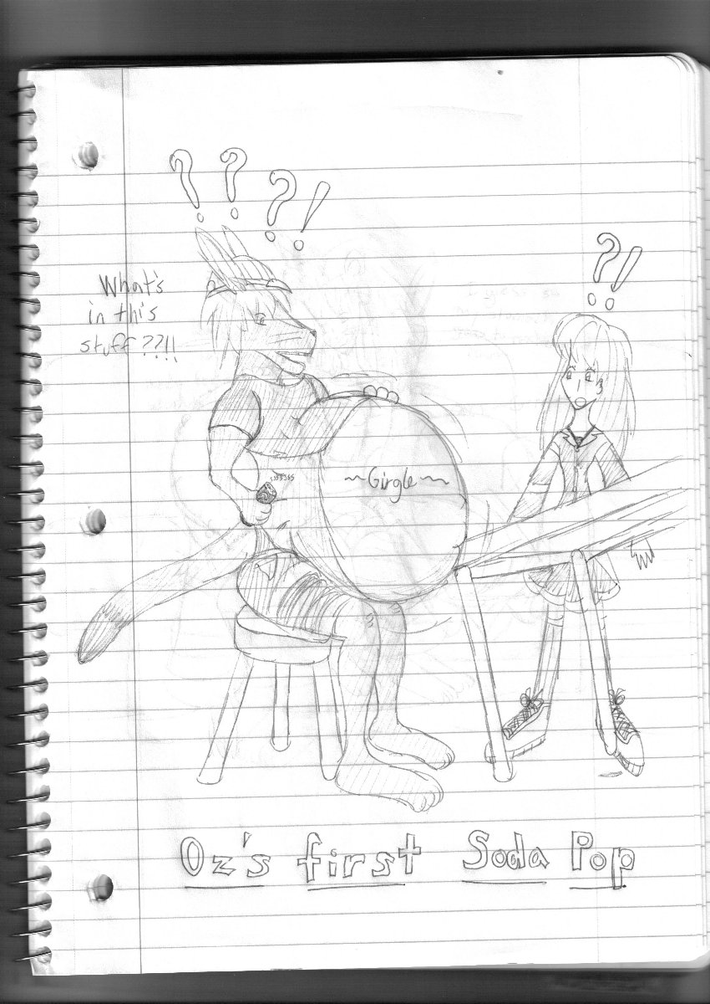
“ Why is this happening?” Alice asked backing up.

It got to the point where he fell over and the belly kept getting bigger and bigger, soon it looked like he had an over inflated beach ball on his stomach.

“ I can’t have anything that gives you gas!” the kangaroo yelled out muffled by his own growing belly.

Alice without question accepted she was nowhere near home and for that matter wasn’t going back anytime soon…

End of chapter…

