You slowly open your eyes to see an unfamiliar sight. Instead of your usual soft bed and bedroom, you were laying down on grass in the middle a large field. Confused by this, you slowly get up off the ground and look at your new surroundings.

You were not prepared for what you saw before you...

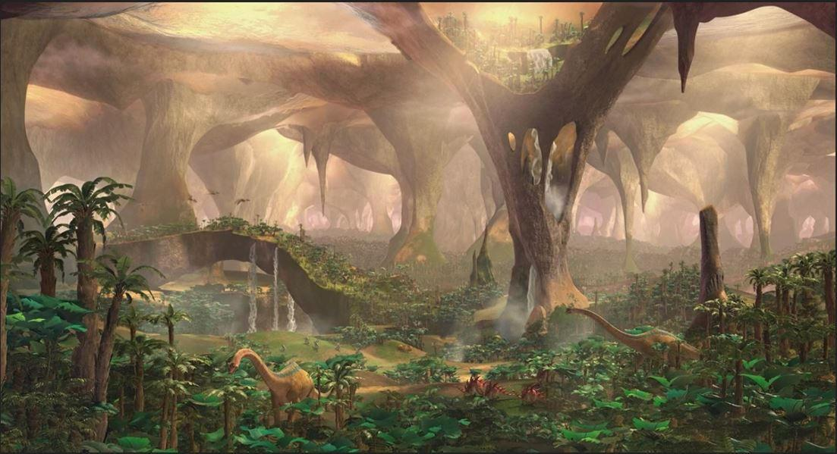

You could only gawk at the sight before you. What you saw before you were creatures thought to have been extinct long ago: dinosaurs. You rubbed your eyes to make sure you were not seeing things, but you weren't. You were really seeing living, breathing dinosaurs! You watched as brontosauruses reached their long necks up to trees to eat the leaves, as a pack of raptors in the distance sneakily hunted down a compsognathus and made it into their meal, as the pteranodons flew by gracefully in the air in search for a nesting ground.

You couldn't understand any of it. How were their living breathing dinosaurs here, and just how did you even GET here? What was when you noticed them: the insects. They were much bigger then usual. You saw a dragonfly that was at least 4ft long flying swiftly along by you. That was when everything made since.

Somehow, you have been transported into prehistoric times!

Your mind began to race about multiple things, about how you got here, about what to do next, but most importantly: how are you going to even survive here? The only thing you did know though, was that you had to get moving. You would get hungry and thirsty soon, and you do not want to be how in the open for larger predators that could attack. With all this in mind, you began to head out.

After a bit of searching, you came across some tasty looking berries in a forest. You began to eat your fill and enjoyed the sweet taste of the succulent berries.

**\*CRUNCH\***

**\*CHOMP\* \*CHOMP\***

Those sounds were enough to unnerve you. You slowly looked over to the source of the loud eating sounds.

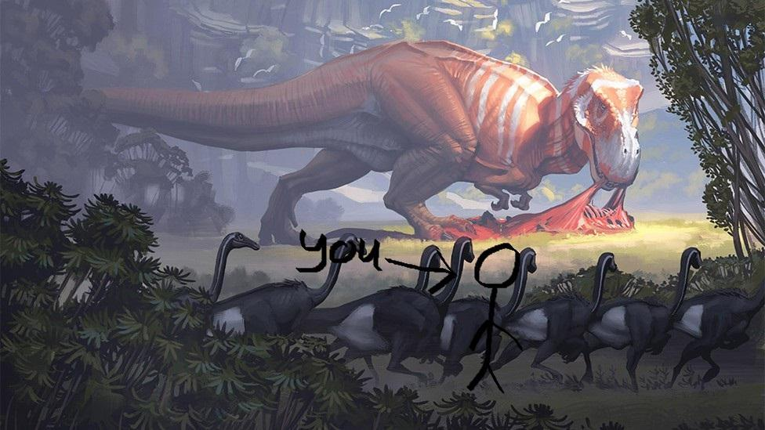

Your fears were confirmed as you saw the T-rex. You watched as it chewed and ate up its latest hunt. You quickly decided that you did not want to be around here any longer and with swift and quiet movement, you stay clear of the rex and leave to another, hopefully safer location.

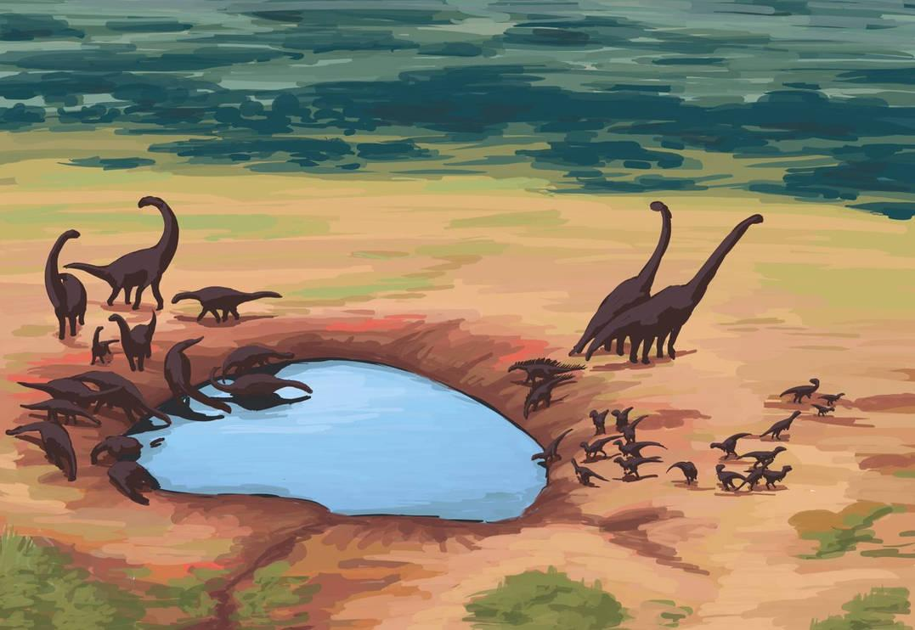

You soon come across a large watering hole where many friendly and peaceful dinosaur seemed to reside at. You approached the hole of water and happily drank up from it, feeling much refreshed and happy. As you rested at the watering hole, you smiled at the sight of being so close to all of these big and friendly dinosaurs, it was such an amazing experience to be so close to such amazing creatures.

**\*ROOOOOAAAAAARRRRRR!!!!!\***

Suddenly, a loud and ground shaking roar was bellowed from nearby. The dinosaur that were currently residing at the watering immediately became alarmed at the sound and ran away quickly. You looked over to the source of the sound and saw it.

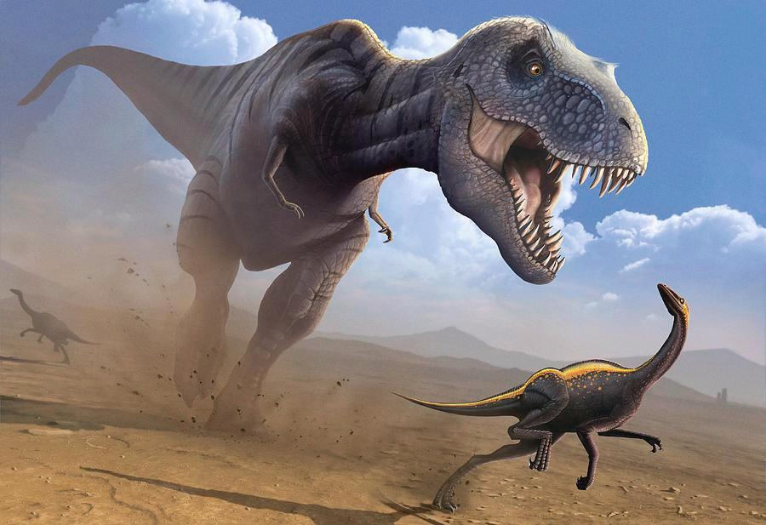

It was the T-rex from before. It was currently chasing a compsognathus towards the watering hole. The compy was trying to run away as fast as possible, but to no avail. The rex snapped its jaws down at the little dinosaur and immediately swallowed it down its throat in one swift gulp.

It was then, that the rex looked over and saw you, it's next easy meal. The rex immediately charged at you full speed, you wanted to run but you were so scared that you could only stare helplessly. The rex approaches you and moves it head down towards you to strike, but just when it was about to chomp down on you, suddenly, a spinosaurus suddenly appeared and rammed right into the rex.

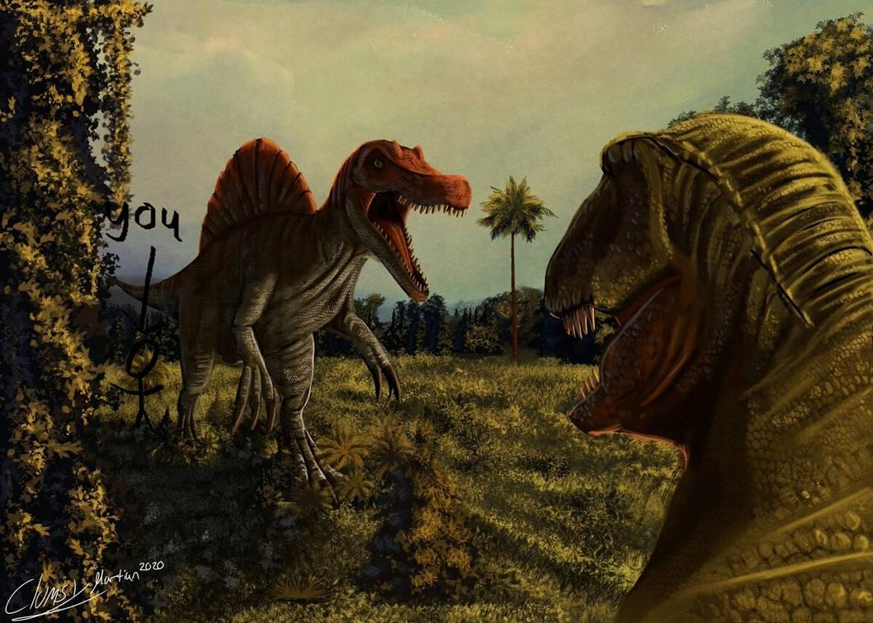

The spino stood defensively in front of you and growled menacingly at the rex. The rex growled just as menacingly right back at the spino. The two began stare down at each other for several moments, neither staggering, before finally the rex seemed to decide that you are not worth the trouble of fighting the spino and leaves.

You sigh in relief for a moment seeing the rex leave, before looking up at the huge spino who was now looking down at you and staring at you with piercing eyes, and you remembered the immediate danger you are still in.

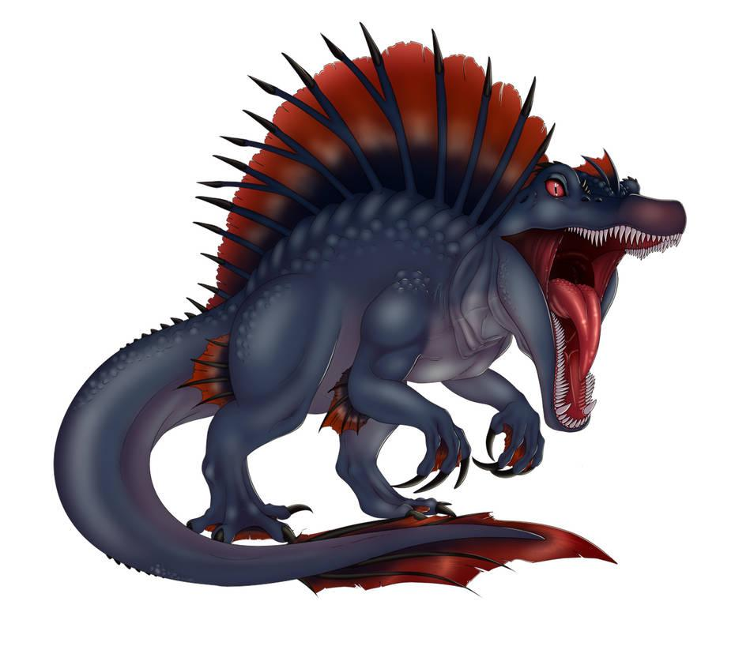

You saw the spino's large and menacingly teeth and fangs jetting out from it's maw, you saw it's piercing blood red eyes with black slits for pupils, and you saw all of its sharp claws on it's arms and legs. The spino was comprised of dark blue scales and a white underbelly. It also had a large red sail and tail fins.

The spino soon leaned it's massive head down towards you, causing you close your eyes and look away in fear while shaking. The spino pressed it's muzzle against your face and... began to nuzzle your face gently?

"Are you ok, little one?" you heard the spino suddenly say in a gentle and friendly female voice.

You look up in surprise to see the huge spino talk to you.

"You can speak?" you say to her.

The spino giggles lightly. "Of course, all of us dino's can speak little one. Some just don't like to speak more then others." She says while looking towards the direction the t-rex went.

You were surprised by this new knowledge about dinosaurs, but you still didn't feel any safer.

"Are... are you going to eat me?" you asked fearfully.

The spino's eyes widened at your question. "Eat you? Goodness, no! Why would I harm such an innocent creature like you? I saw that t-rex attacking you and so I came to help. That t-rex is always such a bully, hunting any small creature lesser then him, so barbaric. Not all us predatory dinosaurs are monsters like him little one."

Upon hearing what she said, you smiled gratefully at her. "Wow! You really saved my life? Thank you so much, miss... uh..."

The spino smiled dearly at you. "My name is Minuette little one and you are very welcome. What is your name little one?"

"My name is [Y/N]. It is a pleasure to meet you Minuette." you reply happily.

Minuette smiles warmly at you and nods. "[Y/N], what an interesting and unique name, I like it very much~. I must say, I have never seen a kind of creature such as you before, are you a new species?"

You begin to tell Minuette your story about how you woke up here and don't belong in this time period. Minuette looked down at you with wide eyes upon hearing all this. She couldn't help but feel bad for you and decided to help you in the best way she could. Minuette reached her clawed hands out to you and hugged you close to her belly.

"Don't you worry little one, you can stay with me. I'll protect you and be your friend and guardian until you find a way back home." she said happily and lovingly to you while giving you a nuzzle with her muzzle.

You smile happily at her affection for you and hug her back. "Really? Aww, thanks so much Minuette. You are a great friend."

Minuette gave you a warm smile before picking you up with her teeth and putting you on her neck before walking off happily with you to her territory.

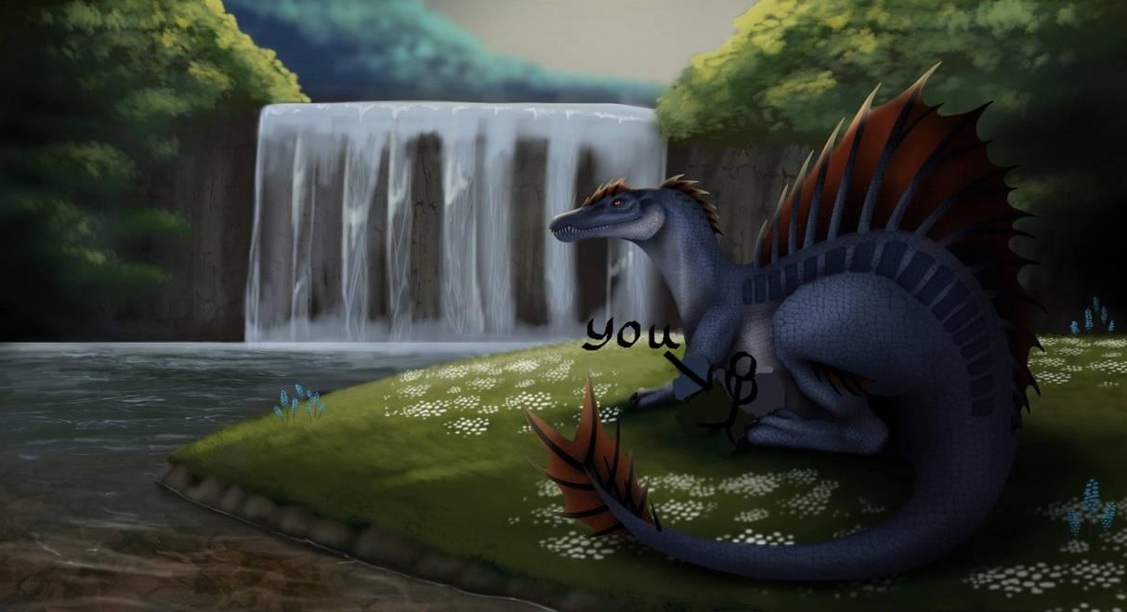

You and Minuette have been laying down together within her home and territory. You leaned against Minuette's warm and soft belly as the two of you talked and learned about about each other. You told Minuette a lot about humans and what life is like in modern society and Minuette told you much about many different dinosaurs, including many thing we've never knew about before. The two of you also talked your personal interests and found you both shared much in common, the two of you were beginning to become really good and close friends.

Soon however, it was becoming night time. As you and Minuette began to go to sleep for the night, you began to shiver in the cold night. Minuette had you held against her belly and wrapped her tail against you to keep you warm, but it wasn't enough for you. Realizing you need a warmer place to stay, she suddenly gets an idea.

"[Y/N], if you would like, I could swallow you and keep you warm inside my belly. I promise you will be safe and I will not digest you." Minuette said sweetly.

You look into her eyes and smile. "That sounds so very nice, I would love to stay inside you Minuette!"

Minuette smiles lovingly down at you before leaning her large head down in front of you. "Alright then [Y/N]..."

Minuette slowly opened her large maw in front of you.

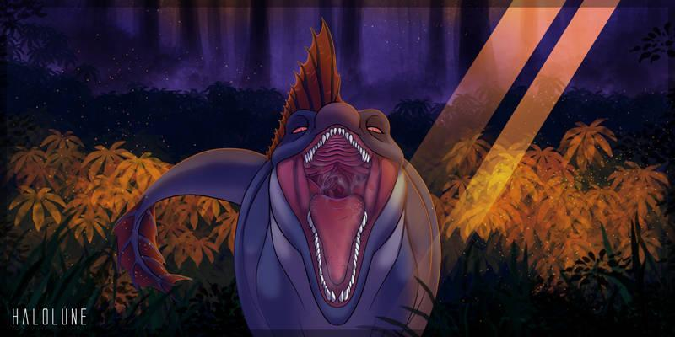

"...Come on in~!" she finished.

You smiled at the sight of Minuette's open maw, it looked so nice and inviting. Without a second thought, you immediately jumped right into her open maw and laid happily down on the center of her warm and slick tongue.

**\*SNAP\***

With a loud 'snap', Minuette shut her maw shut around you, encasing you inside her warm, wet, and toothy maw.

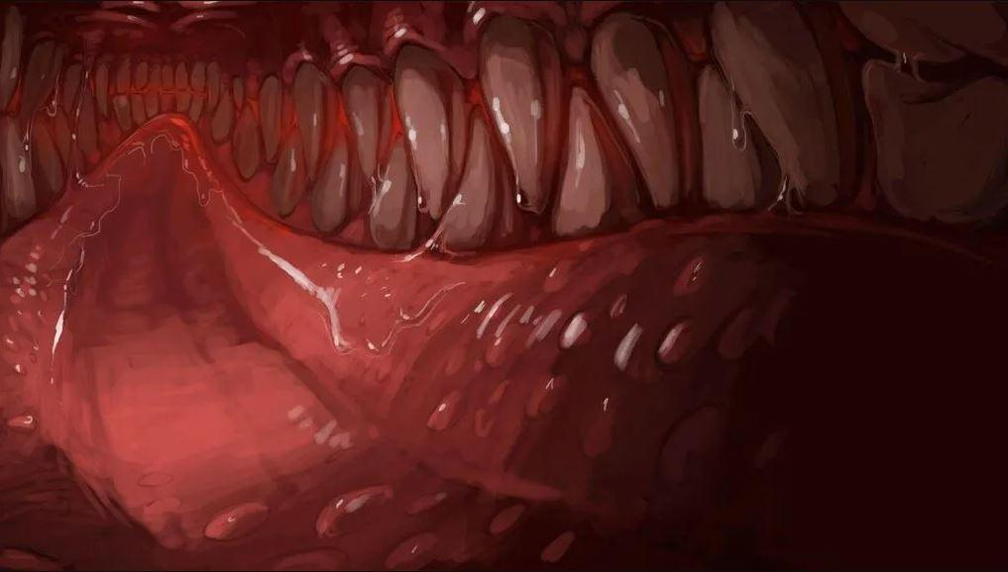

As you laid inside of Minuette's maw, you enjoyed feeling the waves of her warm breath blowing onto your body, her breath also carried a pleasent fishy and meaty scent of her previous meals with it. Minuette's tongue was very soft and spongey. Her tongue was also completely drenched with Spinosaurus saliva, though it was also very warm as well. You also noticed his many very sharp pearly white teeth and fangs that resided within her maw.

Suddenly, Minuette's tongue started to move, and move you with it. Using her tongue, Minuette squished you against her left cheek before moving you again and pushing you against her right cheek. She continued to swish you back and forth in his mouth for a while, with you enjoying every second of it. After a couple minutes she stopped, and then she started to bounce you up and down on her tongue, you laughed as you enjoyed the ride Minuette was giving you, she even trapped you on the roof of her maw for moment letting you stick, before letting go and letting you land with a wet 'splat' on her tongue.

"\*giggles\* did you enjoy all that, [Y/N]? I just had you taste you a bit while you were in there, and YUM! are you delicious~!" Minuette said playfully.

"Hehe, well I am glad you are enjoying me Minuette!" you respond happily to her.

"Indeed, but I've kept you inside my maw for long enough now. It's time to go down the hatch~!" she said and suddenly, you felt gravity shift as Minuette tilted her head up into the air, and you suddenly found yourself sliding down her tongue and towards her throat.

**\*GUUULP\***

With a single big gulp, Minuette swallowed you whole and sent you down her gullet.

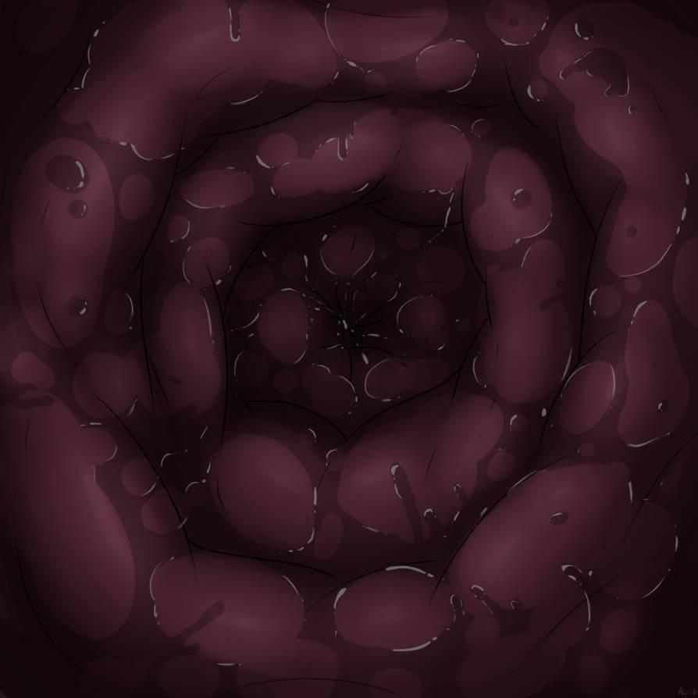

You were now heading down Minuette's throat. You could feel her throat muscles softly but firmly squeeze and push you further and further down. As you were continued down her throat, Minuette was making happy and satisfied noises, clearly enjoying feeling you slide down her throat. On the outside, she was watching as the bulge you made slowly slid down her neck before eventually disappearing into the rest of his big belly. As you started to get closer to Minuette's stomach, you were able to start to hear the sound of her heartbeat become more prominent, as well as her breathing becoming louder, and after a moment, you started to hear soft gurgles and groans coming from her stomach, a sign you were getting close. After another couple moments, you were then abruptly stopped at a small sphincter, before being pushed through it, and finally, you were deposited into Minuette's Stomach.

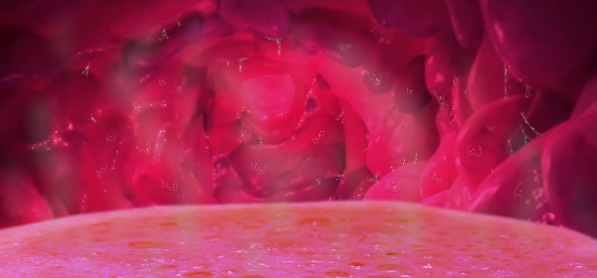

**\*SPLASH\***

You landed with a small splash as you landed directly into the pool of bubbling liquids within Minuette's stomach. After taking a moment to get a baring of your surrounding, you quickly decided to lay back against Minuette's stomach walls and get comfy.

Once you got comfy, you were able to actually start to get a look around around Minuette's stomach. You watched as the stomach walls slowly moved and pulsated around you. You also looked at the pool of liquids, the liquids were all the way up to your shoulders, and yet they didn't hurt or even tingle in the slightest. You also noticed just how hot it was inside her stomach. Minuette's stomach had to be just as hot as a hot tub. You smiled at the warmth and continued to relax in her stomach, and as you did you listen to all of the sounds that accompanied it. you heard Minuette's heartbeat, her breathing, and the soft gurgles and groans of her stomach. With a smile, you moved a hand up to Minuette's stomach walls and give it some nice rubs.

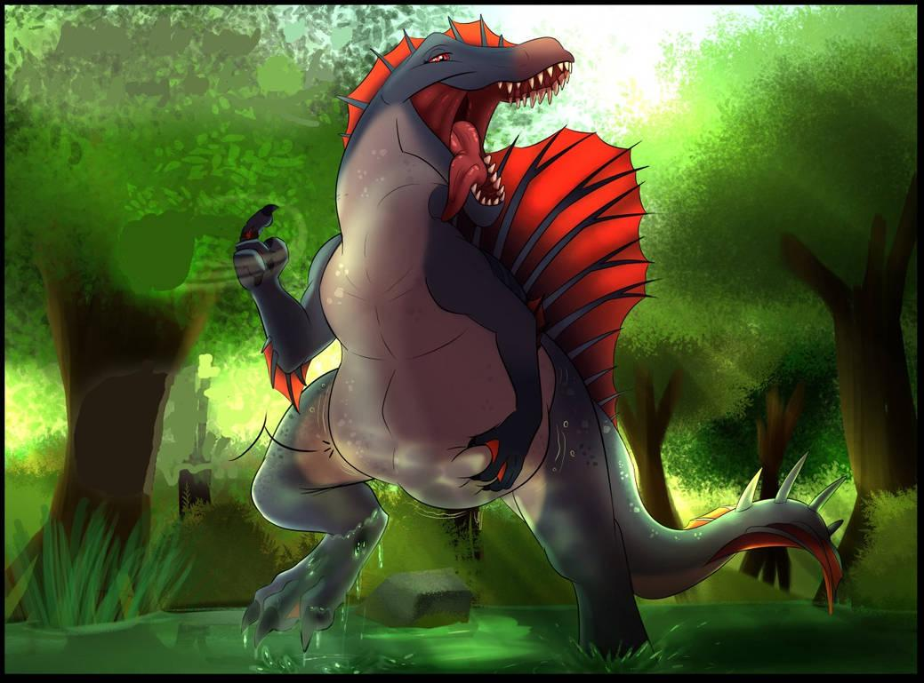

"Ooh~, keep doing that [Y/N], that feels SO good in there~!" Minuette said happily to you.

She moved a clawed hand down to her belly and began to rub it herself, rubbing the bulge you made inside her stomach. You smiled at this and began to rub her belly harder and more thoroughly, causing Minuette to murr and purr more happily and blissfully. Soon, as you were rubbing her belly, it began to stir up a bit and after a moment...

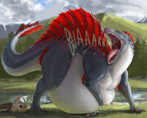

Minuette let out a nice long hearty belch. Minuette giggled at her belch and patted her belly happily.

"\*giggles\* I hope you are comfy and relaxed in there [Y/N], cause you are going to be staying in there allllllll night~." she said.

You let out a loud yawn and smile. "I've never been comfier in my entire life."

"That's good to know. In that case, I'll have you sleep inside my belly every night then! Welcome to your new room [Y/N]! \*giggles\*" Minuette says happily.

Minuette lays back down and curls up on the grass once again.

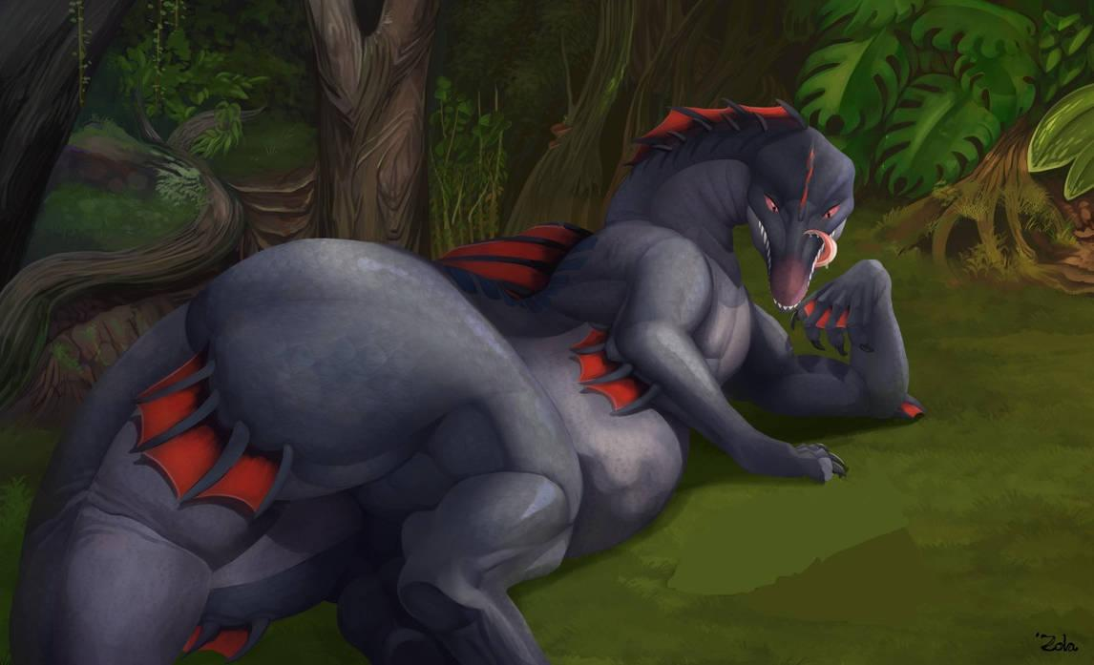

She lets out a big yawn before looking down at her filled belly happily. "Goodnight [Y/N], see you in the morning, my sweet little one."

You smile and nuzzle Minuette's stomach walls. "Goodnight Minuette, and thank you for being here for me. I hope we stay friends forever."

And with that, the two of you fell asleep together, both as happy and close as could be.

THE END